

G H RAISONI COLLEGE OF ENGINEERING & MANAGEMENT, WAGHOLI, PUNE
(An Empowered Autonomous Institute, Affiliated to Savitribai Phule Pune University,
Approved by AICT. New Delhi and Recognized by Govt. of Maharashtra.
NAAC ACCREDIATED A+ Grade)

Department of Information Technology

TAE-2(Project Based Learning)

Subject: Object Oriented Programming 23UITPCL2302

“Cinema Ticket Billing System”

Academic Year 2026-27 Semester-III

G H RAISONI COLLEGE OF ENGINEERING & MANAGEMENT, WAGHOLI, PUNE
(An Empowered Autonomous Institute, Affiliated to Savitribai Phule Pune University,
Approved by AICT. New Delhi and Recognized by Govt. of Maharashtra.
NAAC ACCREDIATED A+ Grade)

Department of Information Technology Academic Year 2026-27

Semester-III

Guided By:-
Prof. Priya Waghmare

Submitted by:

- SYITB61 - Janhvi Singh

- SYITB75 - Krishna Madhrele
INDEX

Sr. No | TITLE | Page No
1. | Input/Source Code with inheritance and file handling
2. | Output/ Results
3. | Conclusion
4. | References
5. | Githublink

Source Code:

#include <iostream>
#include <fstream>
#include <string>
using namespace std;

// Base Class
class Cinema
{
protected:
string theatreName;

public:
Cinema()
{
theatreName = "Galaxy Grand Cinema";
}

void showTheatre()
{
cout << "\n=================================\n";
cout << " " << theatreName << "\n";
cout << "=================================\n";
}
};

// Derived Class
class Movie : public Cinema
{
protected:
string movieName;
string showTime;

public:
Movie()
{
movieName = "Hanuman Ansh";
showTime = "6:30 PM";
}

void showMovie()
{
cout << "Movie Name : " << movieName << endl;
cout << "Show Time : " << showTime << endl;
}
};

// Multilevel Derived Class
class Ticket : public Movie
{
protected:
string customerName;
int tickets;
string seatType;
float price;
float total;

public:
Ticket()
{
tickets = 0;
price = 0;
total = 0;
}

void input()
{
cout << "\nEnter Customer Name: ";
cin >> customerName;

cout << "Enter Number of Tickets: ";
cin >> tickets;

cout << "\nSelect Seat Type:\n";
cout << "1. Regular - Rs. 150\n";
cout << "2. Premium - Rs. 250\n";
cout << "3. VIP - Rs. 400\n";

int choice;
cout << "Enter Choice: ";
cin >> choice;

switch (choice)
{
case 1:
seatType = "Regular";
price = 150;
break;

case 2:
seatType = "Premium";
price = 250;
break;

case 3:
seatType = "VIP";
price = 400;
break;

default:
cout << "Invalid choice! Regular seat selected.\n";
seatType = "Regular";
price = 150;
}

total = tickets * price;
}

void displayBill()
{
showTheatre();
showMovie();

cout << "\n----------- BILL ------------\n";
cout << "Customer Name : " << customerName << endl;
cout << "Seat Type : " << seatType << endl;
cout << "Ticket Price : Rs. " << price << endl;
cout << "Tickets : " << tickets << endl;
cout << "Total Amount : Rs. " << total << endl;
cout << "-----------------------------\n";
}

// Save booking record in file
void saveFile()
{
ofstream file("CinemaBill.txt");

if (!file)
{
cout << "Error opening file!\n";
return;
}

file << "=================================\n";
file << " GALAXY GRAND CINEMA\n";
file << "=================================\n";
file << "Movie Name : " << movieName << endl;
file << "Show Time : " << showTime << endl;
file << "Customer Name : " << customerName << endl;
file << "Seat Type : " << seatType << endl;
file << "Ticket Price : Rs. " << price << endl;
file << "Tickets : " << tickets << endl;
file << "Total Amount : Rs. " << total << endl;
file << "=================================\n";

file.close();

cout << "\nBooking record saved successfully!\n";
}

// Read booking record from file
void readFile()
{
ifstream file("CinemaBill.txt");
string line;

if (!file)
{
cout << "Error opening file!\n";
return;
}

cout << "\n------ BILL FROM FILE ------\n";

while (getline(file, line))
{
cout << line << endl;
}

file.close();
}
};

int main()
{
Ticket t;

t.input();
t.displayBill();
t.saveFile();
t.readFile();

return 0;
}

Output
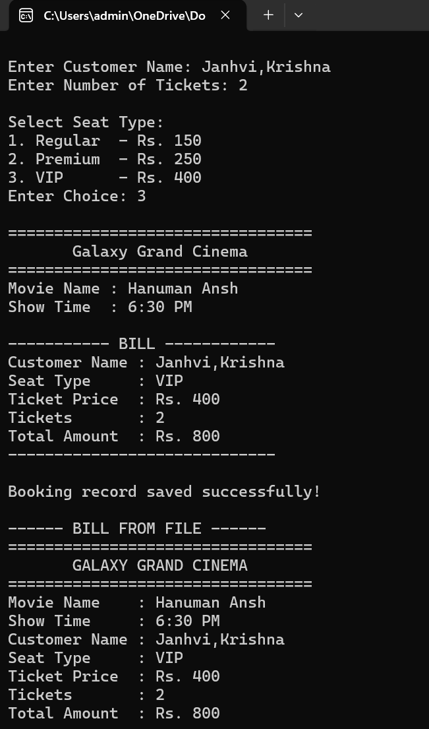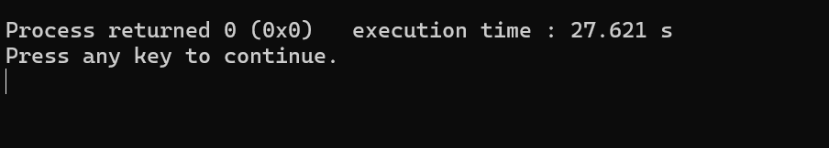

References

- E. Balagurusamy, Object Oriented Programming with C++, McGraw Hill Education.
- C++ documentation and online learning resources for inheritance and file handling.
- GitHub – For studying examples of C++ mini projects and project structures.
- GeeksforGeeks – C++ OOP, inheritance, constructors, and file handling.

Github/Kaggel link:

https://github.com/sjanhvi-singh/Cinema-Ticket-Billing-System

